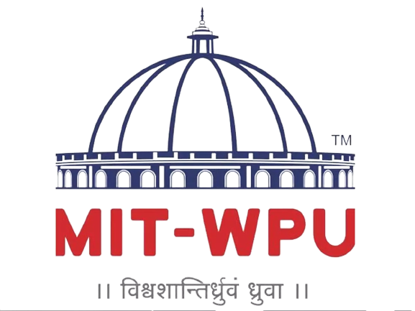

**Design Thinking Lab**

Assignment 3

Efforts by:

Muskan Singh 104013 | Rutuja Gawade 104005 | Division: 4 | Batch: 1

[FY: 2020-2024]

# ABSTRACT:

This report investigates various problems in the farming sector by different kinds of brainstorming techniques which are discussed at length at the beginning of the report. Structured brainstorming by both teammates through various ideas was completed to write the motivation statement over the course of a few weeks. In turn, procedural functional decomposition and finalization of other specifications was followed to reach to a concise product namely “Recreational pumps” with all aspects like its costing, detailed component dissections, hypothetical business goals and every little detail like safety/user guidelines being discussed.

**CONTENTS OF THE REPORT :**

1. Brainstorming [ Types, rules, applications ]
2. Motivation Statement
3. Markets and Hypothetical key business goals
4. Separately generated ideas
5. Rating and selecting the final idea from the others
6. Functional Decomposition
7. Finalisation of design specifications
8. User/Safety Guidelines
9. Detailed Designs
10. Conclusion
11. References

BRAINSTORMING

#### Definition of brainstorming

Brainstorming is a technique implemented by teams where in generation of ideas and putting them down in visual format ensues. Brainstorming pushes one’s brain to come up with ideas and solutions to properly defined design problems. The participants put forth their ideas as they occur to them and then build on the ideas raised by others. All the ideas are noted down with little to no criticism.

Finally, all the ideas are critically evaluated on the grounds of various factors like their logical and economical feasibility, implementable scientific principles etc after the brainstorming session nears to its end. The uniqueness of brainstorming lies in how it uses a set of specific rules and techniques which encourages and sparks off new ideas which would never have happened under normal circumstances.

#### Rules of brainstorming:

1. No idea is rejected in the initial stages.
2. Face to face discussions are avoided to resolve any conflict of interest and accommodate the ideas of less vocal people.
3. Focus on the given topic is strictly adhered to.
4. Immediately Involving everyone is avoided by giving them time to think. 5)Limitations on brainstorming sessions are strictly avoided while everyone is allowed to talk openly without any definitive structure.
5. No ideas are shot down right away. At Least one idea out of each member is encouraged.
6. Quantity over quality is preferred
7. Brainstorming isn’t limited to one small session and allows people to enter in ideas even afterwards when relevant points come to them.

#### Different kinds of brainstorming:

There are numerous brainstorming techniques and any one of the lott can be picked depending on personal convenience and preference.. Naturally, there are techniques and environments which suit certain people better than others but brainstorming is flexible enough to be able to suit everyone if the rules are judiciously followed.

Whether one does brainstorming with a group of excited colleagues or advanced brainstorming alone in an isolated room will depend on personal preferences and circumstances.

Below are some major brainstorming techniques (keeping in mind there are many more as the methodology is more abstract and accommodating to suit the preferences of different individuals and groups who choose to apply it in problem solving):

1. Brain writing

Under brain writing, the team members write down their ideas on a given topic provided to them by the assigned group leader. This ensures that everyone gets the opportunity to come up with something and contribute to the final set of ideas whose implementation shall be contemplated over.

1. Traditional Brainstorming

The normal view of brainstorming is where a group of people sit in a room and shout their ideas out loud as they occur to them. They are told to lose their

inhibitions and that none of their ideas are judged so that people are free to shout out anything and everything without feeling uncomfortable. People should build on the ideas called out by other participants under this technique. Out of the many ideas suggested there, some turn out to be of great value. Because of the

free-thinking environment, the session helps promote new radical ideas which break free from normal ways of thinking.

1. Advanced Brainstorming

Advanced brainstorming builds on the current methods of brainstorming to produce more original ideas in a more efficient way. Specialized techniques, better processes and better awareness, combined with new technologies make traditional brainstorming a less frustrating process. Most of the problems associated with traditional brainstorming disappear as a more effective process is ensued in the advanced version.

Advanced brainstorming uses:

* New processes and new training methods to reduce inhibitions
* Creative and lateral thinking techniques
* Brainstorming software (computer-aided creativity).
* New materials for stimulation and recording ideas

1. Reverse Brainstorming

A creative problem-solving technique in which the problem is turned around and considered from a different point of view to spur new and different solutions.

1. Stop-and-Go Brainstorming

A problem-solving technique in which a group alternately engages in brainstorming

solutions without evaluation for ten minutes then engages in a short period of evaluation. The group continues alternating between brainstorming and evaluation.

1. Team Brainstorming

The team is broken into small groups or pairs to meet for a few minutes and then they are allowed to generate as many ideas as possible within an allotted time frame. The teams may even be given their own dry erase board, poster board or large sheets of paper. Thus the small groups naturally try to come up with the best ideas or the highest number of ideas. And when time is up, each team presents their ideas, also within an allotted time frame. This increases the competitive nature of everyone involved and allows them to produce the best possible output.

Applications of brainstorming in various fields:

Brainstorming has been used to develop the following from various fields of work:

* Advertising campaigns
* Marketing strategy and methods
* Research and Development procedures
* Research techniques
* Patents
* Physical products
* Written documents and articles
* Services
* Processes

## AREA: DESIGNS IN THE FARMING SECTOR

#### List of challenges in agriculture:

* + Capital requirement (land)
  + Lack of appropriate labour
  + Land management
  + Storage of raw materials/products
  + Lack of mechanization of farming tools
  + Protection of harvest from weeds and insects
  + Improper supply of fresh water for irrigation purposes
  + Lack of Water harvesting technologies
  + Proper marketing of harvest
  + Waste Management
  + Fertilizer and manure procuration and usage
  + Soil/Water Erosion
  + Unsustainable usage of various supplies/water/fertilizers

Out of the above challenges, topic decided to work on: Lack of Water Harvesting Technologies

#### Motivation Statement :

The backbone of any farming endeavours is fresh water. The fresh water which aids the irrigation process is a prerequisite for any general crop starting right from paddy, wheat, cotton to sugarcane,oil,tea,coffee etc.

Though an abundance of water is available out there, most of it is unsuitable for irrigation as it's not fresh and thus most farmers rely on rain water as their primary source of watering their crops. The rainwater collected for cropping can be stored for direct use or can be recharged into the groundwater. It makes consistent supply of water for many farmers tough because of irregular rain patterns across the nation.This issue calls for external water harvesting needed for farming. Other sources of fresh water like: rivers, lakes and groundwater are coined as secondary sources which can be tapped by harvesting them for efficient irrigation. Tapping groundwater is seemingly one of the better choices as underground water

replenishes itself through seasonal rains and provides a premade natural storage for storing it.

But to harvest underground water, manual pumps are needed making it extremely laborious to extract water in those quantities. Similar problems are encountered with other water harvesting methods as well. This project tries to resolve some specific issues regarding underwater harvesting to use it as a source of irrigation in farming .

Precise problem statement - Farmers are unable to access ample amounts of fresh water to irrigate their crops from underground sources because the quantities needed to farm demand strenuous labour and manual work making it infeasible for them to use it as a sufficient source for irrigation.

#### Black Box representation of Problem Statement:

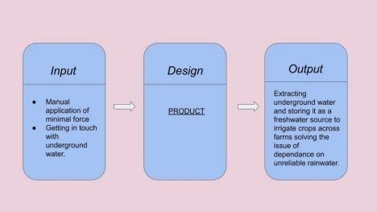

[Figure 1] : BlackBox Representation

#### Primary Market:

* + Large Scale farmers
  + Farmers’ organizations:

For example:

* + - Indian Council of Agricultural Research
    - Bharatiya Kisan Union
    - National Institute of Agricultural Extension Management
    - Agricultural produce market committee
  + Farming NGOs: For example:
    - Haurtika
    - Manuvikasa
    - AARDE Foundation

#### Secondary Market:

* + Animal barns/farms in villages
  + Any industry requiring fresh water

For example: cottage industries needing water

* + Remote areas with improper supply

#### Hypothetical Key Business goal:

* + To establish at least 3 such pumps per 5 hectares in northern states of productivity rich farms.
  + To sell upto 500 units of the pumps in the first year.
  + Expansion of sales and establishments to different terranial states
  + Expanding production centres across the country

#### List of key Stakeholders:

* + Farmers
  + Laborers
  + Transporters
  + Middlemen supplying components
  + Retailers
  + NGOs/Farmers Organizations
  + Local authorities owning lands for needful establishment

## SEPARATELY GENERATED AND RECORDED IDEAS

#### Fog harvesting:

To make fog collection happen by collecting water from fog using large pieces of vertical mesh net to make the fog-droplets flow down towards a trough below, known as a fog fence, fog collector or fog net. Through condensation, atmospheric water vapour from the air would condense on cold surfaces into droplets of liquid water known as dew. This technique could be useful majorly for conserving water in the hilly regions.

#### Spring water harvesting:

To extract water from via a protected spring from small to large scale water bodies. Would be cheaper than a well or borehole.

#### Channel reservoir:

To store water in a channel aimed to support irrigation for agriculture. Channel reservoirs can also reduce the flow of the stream or river from upstream to the downstream areas. Consequently, it may also provide a positive impact on flood reduction in the downstream areas. The harvested water during the rainy season can be used to supply water for agricultural areas and domestic uses during the dry season.

#### Infiltration ditch:

A linear ditch that would collect rainwater from adjacent surfaces and its highly permeable soil material would allow water to quickly seep into the ground. This technique will:

* 1. collect surface runoff (b)source of irrigation water and

(c)contribute to recharge groundwater

Although this innovative technique is addressed to collect water for irrigation of crops, another important role of this technique is that it

contributes to groundwater recharge as well.

#### Recreational Pumps:

To extract ground water through a seesaw mechanism instead of a traditional hand pump which requires one to put in dedicated effort to extract water the work of which can simply be cut down by using water extracted by pushing of the same lever in hand pumps via seesaws utilized by children for recreational purposes.

## QUESTIONS ON WHICH IDEA IS EVALUATED

Q1) How practical is the idea?

Q2) Does it satisfy the problem statement and the user needs? Q3) How cost efficient is the idea?

Q4) Gray areas or loopholes in the idea? Q5)Manufacturing feasibility of the idea?

***[SCORING OUT OF 5 FOR EACH QUESTION PER IDEA]***

[Table 1]: Score of each idea proposed

|  |  |  |  |  |  |
| --- | --- | --- | --- | --- | --- |
| **Score given by** | Idea 1  FOG HARVESTING | Idea 2  SPRING WATER HARVESTING | Idea 3  CHANNEL RESERVOIR | Idea 4  INFILTRATI ON DITCH | Idea 5  RECREATION AL PUMPS |
| Muskan Singh | 23 | 15 | 16 | 21 | 25 |
| Swarada Kulkarni | 21 | 17 | 18 | 21 | 25 |
| Rutuja Gawade | 24 | 12 | 15 | 22 | 25 |
| TOTAL(out of 75): | 68 | 44 | 49 | 64 | 75 |

## GENERATION & EVALUATION OF ALTERNATIVES

*Selected idea: Recreational Pumps*

#### Aim and Objective:

* List subsystems or Give architecture of the selected idea (Try to use tools like Functional

representation / functional decomposition / Physical Decomposition)

* Propose alternatives in various sub systems or parts or materials in the finalized idea.
* Compare those alternatives for each using suitable systematic evaluation method and

show the selection of the alternative based on the workout

* Discuss decision and changes made in design from consideration of cost
* Discuss decision and changes made in design from consideration of sustainability
* Discuss decision and changes made in design from consideration of aesthetic

#### Functional Decomposition

##### Overall Function of the pump:

The pump is designed to mitigate water scarcity problems in villages with no clean surface water source, no electricity and poor monetary capacity. Attached below a merry-go-round wheel/seesaw type interface, is an arrangement similar to a conventional hand pump. As children ride on these wheels or motion the see saw, just like a conventional hand pump moved by human labour, groundwater is drawn and the tank (around 8-10 meters above ground) is filled up. It can also be used to pump water from bore wells and large storage tankers. The water thus acquired can easily be usable to irrigate crops. It can be installed in remote areas and has low maintenance costs. It’s basically a community structure and can be set up in schools, parks, villages and relief camps.

##### Functional subsystems of the recreational pumps:

There are 4 main functional parts of the pump mechanics:

* + Water drawing mechanism: Easily movable and fun lever/rotational mechanics that can be used by children to motion the pump into having the requisite mechanical energy.
  + Storage of water collected: To store the collected water at a height from where it can be used for irrigation.
  + Internal transport of water within the system: Structures of different sizes and lengths to carry water, both: to and from the system. Also arranged in a fashion which would facilitate suctioning of underground water.
* Suction to pump water up: To hold and create a suction which would channel the mechanical energy input by the children to move the lever by connecting it to the internal spring - valve system to push water upwards. It also holds the system of pipes and springs required for the same.

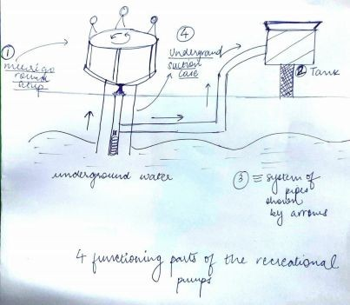

[Figure 2]: vague physical breakdown concluded from the functional breakdown

**Components and their alternatives:**

#### Water drawing mechanism:

* + - Merry Go Rounds
    - See Saw
    - Cycle run levers

#### Storage of water collected: (Tanks)

Shape and height:

Normal Cylindrical tank at a height a little above the ground from where gravitationally supported waterflow can occur.

Material used to make the tank:

* + - Stainless Steel
    - Fiberglass
    - Concrete
    - PVC
    - Galvanized Steel

#### Internal transport of water within the system: (System of pipes)

* + - Cast iron Pipe
    - Foam Core Pipes
    - Wrought Iron Pipe
    - Steel Pipe
    - Copper Pipe
    - Plastic Pipe
    - Asbestos Cement Pipe
    - Concrete Pipe
    - Vitrified Clay Pipe

#### Underground suction case:

A sustainable case for the internal pipes and springs that will help the water and thus will be made of rigid untarnishable foam core material.

##### Evaluation & Consideration:

* + Children’s interface: Merry Go Rounds would be the most efficient of all as they are the easiest to be played with while providing the largest amount of water suction to drive water through as compared to others all while allowing easier mechanical work to generate bigger outputs.
  + Tank: To store the collected water Polyvinyl chloride (PVC) tanks should

be used because they are cheap, easy to maintain, aesthetic due to colour variety as well as very long lasting.

* + System of pipes: A combination of differently shaped pipes of foam core should be used because foam core pipes are basically multilayer pipes having outer and inner layers of conventional PVC and middle layer of foamed PVC. Outer and inner layers are designed to take the load while the middle layer of foamed PVC gives rigidity while maintaining the shape of the pipe under load, it reduces the total weight of pipe and makes it light when compared to solid wall PVC pipes. Not only does it make them durable and sustainable but also cheaper and aesthetic
  + Underground suction case: Set up of similar materials as the tanks and pipes to maintain continuity of design and keep the availability of the raw materials of the whole system convenient.

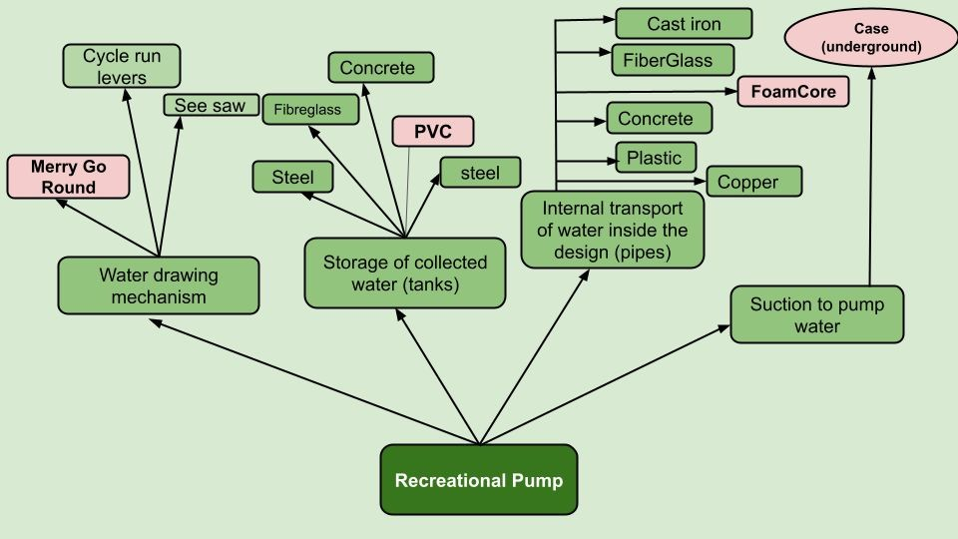

[Figure 3: Tree Diagram for the functional decomposition into subcomponents and finalized components]

## FINALISATION OF DESIGN SPECIFICATIONS:

#### Finalisation of Design Specifications:

Aim and Objective:

Finalising the specifications of the design and proposing the approximate costing (in terms of percentage of total cost ) and providing safety guidelines and proceed for testing the mechanism.

### Finalisation of specifications

* Components:
  + Galvanised steel or iron handles
  + Wooden disk
  + Foam core pipes of different shapes and sizes
  + Axle Hubs
  + Small Wheels
  + Cylinders
  + Foot Valves
  + Piston Valves
  + Galvanised Steel cylinder
    - Self actuated pressure induced valves (galvanised steel)
  + Suction Lifts
  + Screws, nuts and Bolts
  + Ladder
* Material:
  + Iron
  + Galvanized Steel
  + Foam Core
  + Oak Wood
* Manufacturing:
  + Iron or Steel Handles
  + Wooden multi layered disk base
  + Custom Foam Core pipes
  + Custom valves and pistons
  + Internal cylinder
* Maintenance:

Very self sustaining machine with maintenance of mechanical merry go round and internal cylinder required only once in 6 to 12 months in the form of a small inspection.

### Costing(In terms of total cost)

* + Components & Material - 45%
  + Assembly - 20%
  + Maintenance - 10%
  + Manufacturing - 25%

### Technical Specifications:

* + Diameter of merry go round disk: 2-3 metres
  + Height of the axle hub: 35cm
  + Diameter of Small Wheels: 20cm (4 needed)
  + Moulded iron handle: 4.5 ft length and 5cm diameter (6 needed)
  + Foam Core pipes of :

20cm diameter

15cm diameter

* + Self actuated pressure induced valves of 20cm (2 needed)
  + Diameter of internal cylinder: 30cm
  + Load Capacity: 400 kgs
  + Base Disk Material: Oak Wood
  + Handle material: Iron/Galvanized Steel
  + Tank Material (including attached Ladder): PVC
  + Pipe Material: Foam Core
  + Internal cylinder and valve material: Foam Core
  + Coating: Galvanised Steel

### Commercial Specifications

* + Manufacturing cost of each unit: Rs 600 (in bulk)
  + Final Marked Price of each unit: Rs 4000/piece

### User Guidelines

* + Children between the ages of 7 and 18 can use the circular interface in the form of a merry go round by slowly mounting it in groups of 2 to 12 and giving it manual circular acceleration either internally or externally triggering the internal pumping mechanism.
  + The internal pumping and water storage mechanism is automatic and doesn’t need external interference.
  + The PVC water storage tanks’ water can be extracted for irrigation or

drinking purposes through different pipes and mechanisms including smaller pipes or other methods as and when required.

* + The PVC water storage tanks’ ladders are for cleaning of the tank every 4-8 weeks to avoid contamination of stored water to ensure its usage for both irrigation and common water drinking practises by improvised orifices.
  + Thoroughly testing the machines before their installation to make sure there are no defects.
  + The machines should be installed by the organizations and individuals only at flat surfaces having approved levels of groundwater. It should also be noted that a prior cleaning process before pump installation will ensure that no particles enter the internal system.

### Safety Guidelines

* + Children above the age of 18 should be prohibited from using the merry-go-round-pump to avoid putting large pressures on the system.
  + Children below the age of 5 should also be prohibited from using the pump to play as it might prove dangerous because of the speeding highs the merry go round can hit.
  + It is advised for the children to play under the supervision of an adult to avoid any mishaps.
  + Stepping on the merry-go-round before it is slower than a safe circular velocity should also be avoided.
  + If an extra velocity is provided to the pump’s merry go round externally, then crossing unsafe accelerations should be avoided as well.
  + No one should attempt to climb the tank’s ladder, especially children.

**Detailed Design**

*(Subparts and major components included)*

#### [Next pages of this pdf include sketches and blueprints of various subparts and the final design the team has come up with]

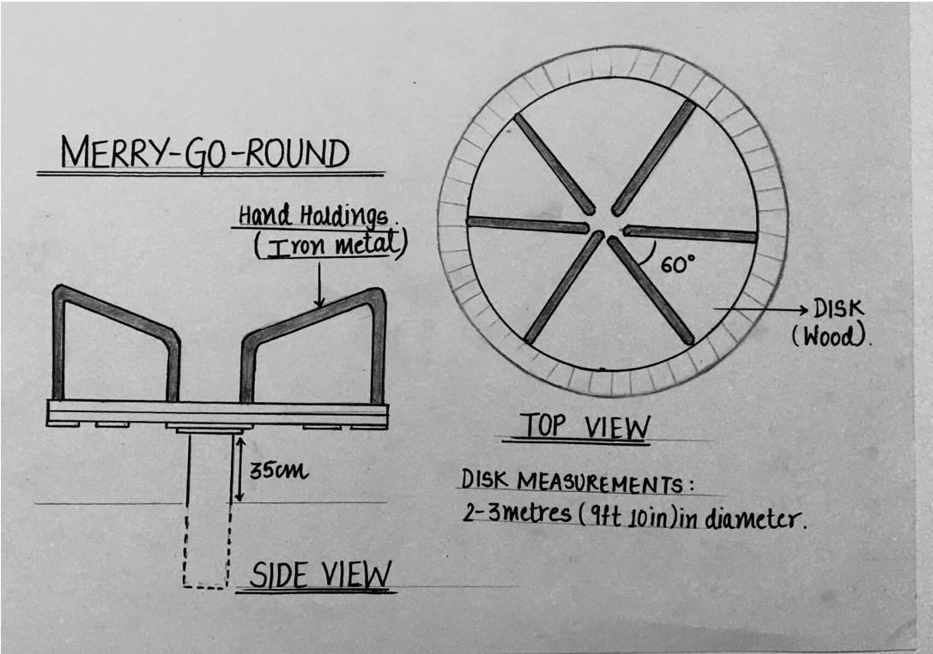

[Figure 4]: Detailed top view of merry go round.

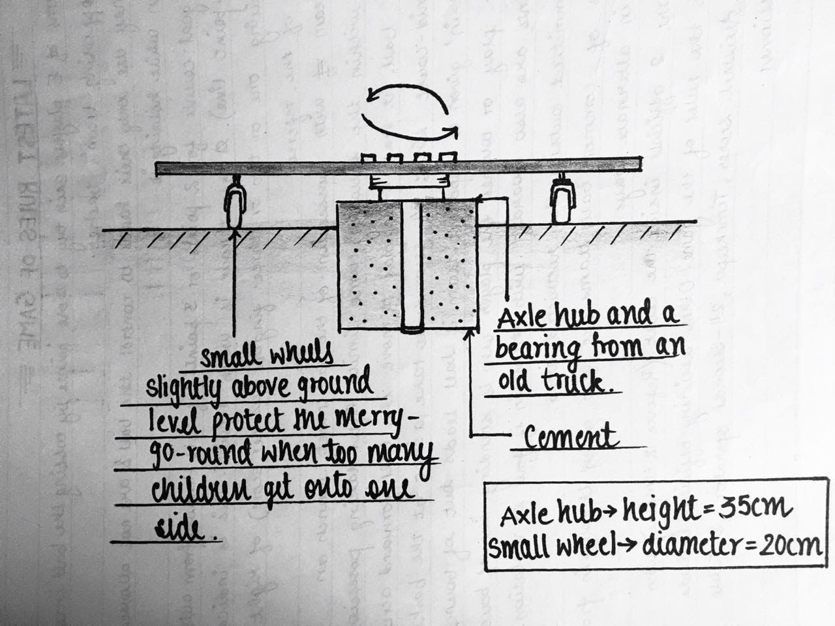

[Figure 5]: Detailed side view of merry go round

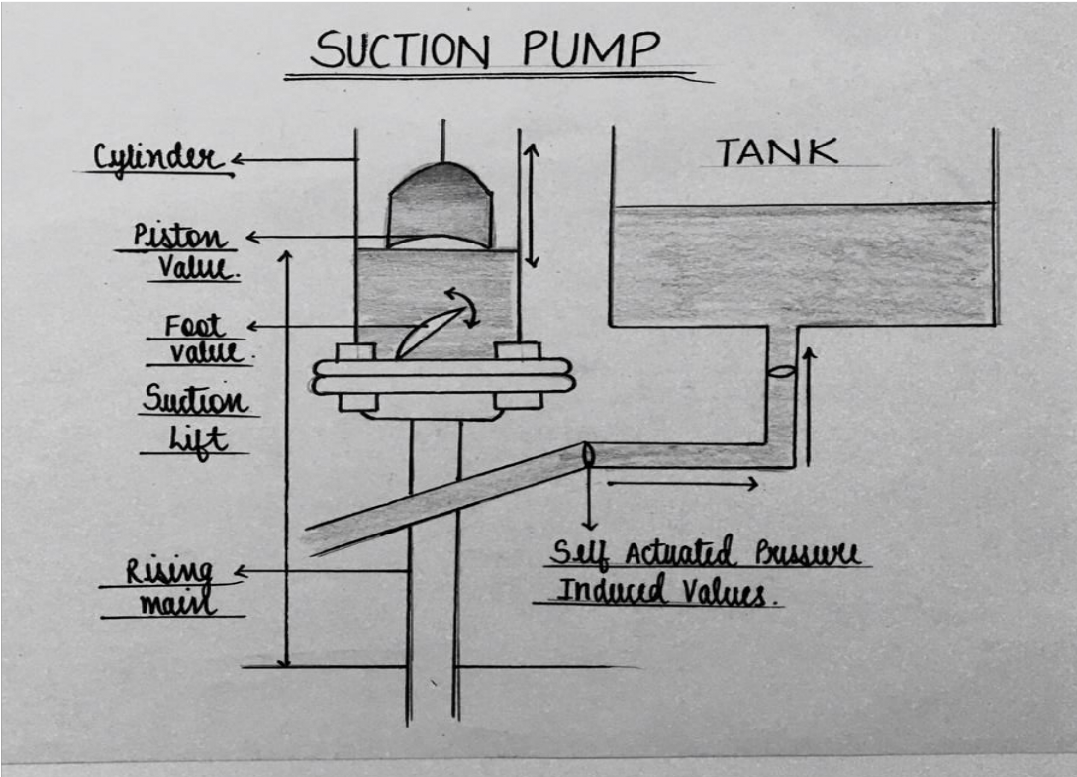

[Figure 6]: Detailed view of underground suction pump

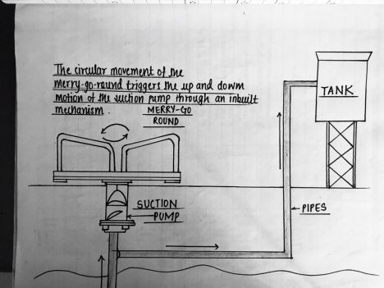

[Figure 7]: Final Blueprint of the product with all its semantics and design details

# CONCLUSION:

Thus, after applying traditional & unique brainstorming methods in the area of agriculture over all possible problems and their solutions, the idea conclusively theorized by the team through this report is “recreational pumps” which through the process of this report’s detailed swotting came out to be as highly efficient and user friendly as possible. The design thus successfully mitigates water scarcity problems in rural areas with no clean surface water source. It can also be used to pump water from bore wells and storage tanks with the same ease. It is easy to set up with low maintenance costs in schools, villages, parks, farms and many more places.

This project and report has been made over weeks of detailed research and efforts and would not have been possible without the efforts and tutelage of our DTL faculty and the help provided by MIT WPU’s infrastructure, guidance and motivation.

# REFERENCES:

<http://bhoomimagazine.org/2017/04/01/traditional-and-innovative-water-conservation-methods-in-india/> <https://www.letsendorse.com/innovation/innovative-see-saw-mechanism-to-pump-groundwater>

[https://csrbox.org/India-CSR-projects-proposal_Span-Pumps-Private-Limited_School-Drinking-and-San](https://csrbox.org/India-CSR-projects-proposal_Span-Pumps-Private-Limited_School-Drinking-and-Sanitation-Water_179) [itation-Water_179](https://csrbox.org/India-CSR-projects-proposal_Span-Pumps-Private-Limited_School-Drinking-and-Sanitation-Water_179)

<https://spanpumpsindia.com/joy-pump-see-saw-pump/>

*Thankyou [END]*